Program Staff

Name | Roles | E-mail
Elizabeth Lutz | Overall project oversight and fiscal oversight | Elizabeth.lutz@healthcollaborative.net
Alejandra Mora | Project management, community engagement, progress reporting | Alejandra.mora@healthcollaborative.net
Jessica Rios | Project coordination, community engagement | Jessica.rios@healthcollaborative.net

Organizations List

Name | Primary Representative
COSA | Sara Wamsley
CI:Now | Dr. Laura McKieran
UT School of Public Health | Dr. Jack Tsai
UTSA - IDSER/Texas Demographic Center | Dr. Llyod Potter / Dr. Po-Chun Huang
UTSA - The College for Health, Community and Policy (HCAP) | Dr. Lynne Cossman
University Health System | Dr. Carol Huber / Dr. Luis Lopez
University of Incarnate Word - Nursing | Dr. Linda Hook
San Antonio Metropolitan Health District | Dr. Anita Kurian
San Antonio Metropolitan Health District (Data) | Dr. Golareh Agha
Texas A&M | Bryan Bales
San Antonio Faith Based Initiative | Rev. Anne Helmke
NAMI | Doug Beach
South Central (AHEC) | Paula Winkler
SACADA | Terri Mebrito
AACN | Cara McGrain
SACRD | Bill Neely
Thrive Youth Center | Greg Casillas
San Antonio Pride Center | Robert Saucedo
United Way | Michael Michelle
Big Mommas house | Rose Williams
UTHSC-SA | Ana Sandoval
Health Collaborative Board | Esmeralda Perez
 | Palmira Arellano
 | Pilar Oates
Health Resource In Action | Camerino Salazar
Timeline

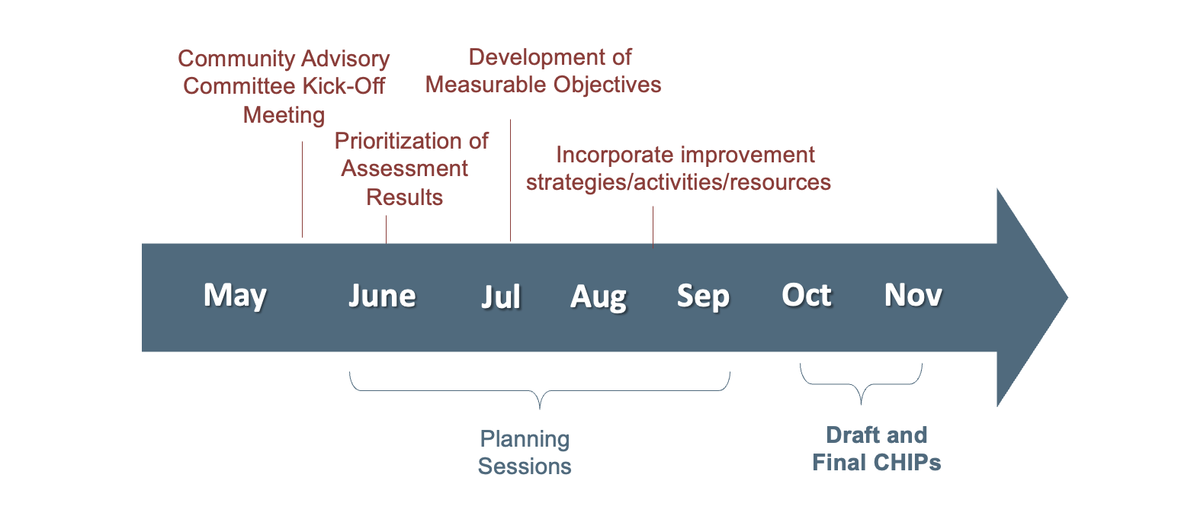

 | Date | Task
 | May 19, 2023 | CHIP timeline and list of organizations deadline
 | June 1, 2023 | Contact steering committee and partner list
 | July 1, 2023 | Organize focus groups and surveys
 | August 1, 2023 | Input data from focus groups and surveys
 | September 1, 2023 | Draft CHIP
 | September 30, 2023 | Summary Report of Engagement Activities (Word file)
 | October 1, 2023 | Review CHIP (submit to City for review)
 | November 1, 2023 | CHIP submission deadline

